**EXERCISE NO: 3**

**DATE: 15/10/2020**

**AIM:**

To remove and print every second number from a list of numbers until the list becomes empty.

**PROGRAM:**

def removeThirdNumber(int_list):

position = 2 - 1

index = 0

len_list = (len(int_list))

while len_list>0:

index = (position+index)%len_list

print(int_list.pop(index))

len_list -= 1

n = int(input("Enter number of elements:"))

int_list = []

for i in range(n):

int_list.append(int(input()))

removeThirdNumber(int_list)

**LINK:** [http://103.53.53.18/mod/vpl/forms/edit.php?id=231&userid=1695#](http://103.53.53.18/mod/vpl/forms/edit.php?id=231&userid=1695%23)

**OUTPUT:**

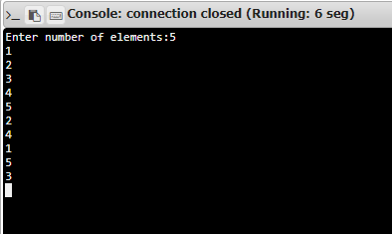

**RESULT:**

Thus, every second number from a list of numbers is removed and the output is displayed.